EMBARGOED UNTIL 00:01 BST TUESDAY 19 MAY 2026
Powerful link between creativity and health uncovered – with one in two people missing out on significant benefits
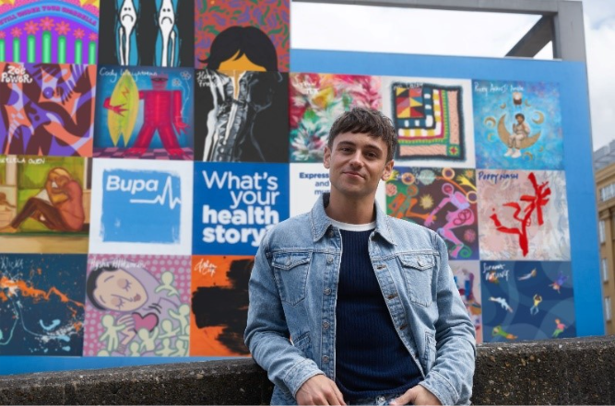
- New research from Bupa highlights how creative activities like art can help people process and share health experiences, with four in five (85%) agreeing that creativity can support mental and physical health
- One of Europe’s largest hand-painted murals (equivalent to 22 double decker buses) spotlights health stories from 21 artists and storytellers, including Tom Daley, Sophie Tea, Yinka Ilori, Cody Weightman and Coco Dávez – with global activations in Madrid, Melbourne and Sydney
- Bupa invites the public to take 30 minutes to get creative, express their health story at bupa.com/express, and experience the health benefits
London, UK, Tuesday 19 May 2026: New global research reveals millions are missing out on the physical and mental health benefits of engaging in creative activities, with almost half (47%) not spending any time on creative hobbies.
Research, commissioned by Bupa, polling 4,000 adults across the UK, Spain and Australia highlights the power of creativity on health and wellbeing. Almost three quarters (71%) say they would benefit from more opportunities to be creative in daily life, with over half (58%) feeling relaxed and calm when participating in activities like art. Meanwhile, 76% say that having a creative outlet helps them better process their emotions and 83% say it reduces stress and anxiety.
Despite four in five people (85%) recognising their creative hobbies like drawing, doodling, painting or crafts positively impact health and wellbeing, over half (55%) of those who don’t regularly make time for creative activities can’t remember the last time they did any. For those that do remember, the last time was over a year ago (35%).
Almost half (47%) of people don’t spend any time on creative activities, with around a quarter noting that lack of time (24%), lack of inspiration (26%) and tiredness after work (28%) are some of the biggest barriers.
The findings spotlight a strong yet often overlooked connection between creativity and health, and coincide with the launch of Express Your Health – Bupa's new campaign celebrating creativity as a powerful way to share health experiences and encouraging people to open up so they can feel less alone and empowered to seek care.
The campaign launched today with one of Europe’s largest hand-painted murals in Waterloo, London – equivalent to 22 double decker buses – created in collaboration with Global Street Art. The mural brings together 21 artists and storytellers from around the world, each sharing a personal health story through their artwork.
Contributors include Olympic diver and knitting enthusiast Tom Daley, renowned artists such as Sophie Tea, Yinka Ilori and Coco Dávez, and athletes including Australian Football League player Cody Weightman. The mural represents stories spanning fertility, sickle cell, diabetes, anxiety, ageing, grief, and more, showing how art can express the physical, mental and emotional sides of health.
Tom Daley, who contributed a knitted tapestry to the campaign, commented, “Knitting started as a way to relax and focus during intense periods of training, but it quickly had a deeper impact on my health. Over the years it has helped me manage stress, boost my mood, and enabled me to process experiences when I couldn't find the words. I hope this campaign from Bupa inspires others to try creativity and see how small moments can make a real difference.”
Global studies are increasingly showing that even short bursts of creativity can benefit health. 30–45 minutes of activities like art, regardless of skill, has been shown to reduce stress and anxiety, with measurable drops in physiological markers of stress including the hormone cortisol. Other research shows art can support mental wellbeing and help people process life experiences and emotions.
Katherine Templar Lewis, creative neuroscientist at Kinda Studios, said, “Scientific research shows that creative activity isn’t just enjoyable it can have measurable effects on the body and mind. Even short periods, 30-45 minutes of creativity, regardless of skill level, have been shown to reduce stress, including lowering cortisol, and support emotional regulation. Activities such as drawing and painting can also engage brain systems involved in self-reflection and emotional processing, helping people make sense of complex feelings and life experiences.”
Fiona Bosman, Group Brand Director at Bupa, said, “This work highlights something we see globally: when people are given the space to share their health experiences, it can be transformative. Through this campaign, we’re encouraging people to express themselves creatively, because when words are hard to find, creativity can help us process, communicate and connect, and ultimately take greater control of our health.”
Bupa is inviting people around the world to share their health story through creativity and art at bupa.com/express where it will become part of a global collection. To help inspire people, the site includes tips and advice on how to start a creative activity.
Bupa has also partnered with D&AD, the global non-profit championing excellence in design and commercial creativity, to launch its upcoming New Blood Awards brief. The New Blood Awards is D&AD's global programme connecting education and industry, challenging students and emerging creatives to tackle real briefs from real brands.
– ENDS –
The research was carried out by Opinium. 4,000 people were surveyed online in the UK, Spain and Australia. Quotas were set to ensure respondents were nationally representative of age (18+), gender and region for each country. Fieldwork took place between 13-20 April 2026.
-----------------------------------------------------------------------------------------------------
About Bupa
Established in 1947, Bupa's purpose is helping people live longer, healthier, happier lives and making a better world. We are an international healthcare company serving 68 million customers worldwide. With no shareholders, we reinvest profits into providing more and better healthcare for the benefit of current and future customers. Bupa has businesses around the world, principally in Australia, the UK, Spain, Poland, Chile, Hong Kong SAR, India, Türkiye, Brazil, Mexico and New Zealand. We also have associate businesses in Saudi Arabia.
About Kinda Studios
Kinda Studios is the first women-led neuroaesthetics studio applying neuroscience research into creative projects to enhance the impact of arts, culture and technology on wellbeing and connection. Their studio transforms scientific insights into strategies, experiences and curation, while their lab uses mobile brain-body technology to test, iterate, amplify and validate these in real-world environments. As a bridge between academic labs and the creative sector, Kinda’s dynamic approach turns neuroscience into more meaningful ideas and innovations. Working with partners at the forefront of science, technology and the creative arts, they are pioneering new interdisciplinary models to maximise impact.
Katherine Templar Lewis bio
Katherine Templar Lewis is a cognitive and human scientist, best-selling author and science communicator. An expert in neuroscience and the new field of neuroaesthetics, her research bridges academia and the real world. Described as “radically optimistic” by New Scientist, she pushes the boundaries of science, accelerating it out of the labs and into design thinking, creating cross-disciplinary teams to bring scientific research to life. Co-founder of the women led Kinda Studios and lab, she is also a regular science and technology expert across media including Sky, BBC, NBC, CNN, and BBC Radio 4. Author of the Uncertainty Toolkit, Katherine believes that by deepening our understanding of mind and body, we can create more human-centred design solutions to drive change and promote human flourishing.
About Global Street Art
Global Street Art is Europe’s leading hand-painted mural company. Their incredible team of artists design and paint murals all over the world for some of today's biggest brands including adidas, Chanel and Netflix. They work in over 25 countries worldwide, with offices in London, Paris, Brussels and Madrid. They run a global portfolio of exclusive media sites.
Global Street Art is fuelled by a belief that art in public spaces has power - and as part of their mission to “Live in Painted Cities” they have produced over 3,000 public art murals, including through their Art For Estates programme, which transforms blank and unloved walls in housing estates with art, and two editions of London Mural Festival – the UK’s biggest street art festival. globalstreetart.com
About D&AD
D&AD is a global creativity non-profit that celebrates, stimulates and enables excellence in design and commercial creativity. Through its world-renowned Awards and education programmes, D&AD aims to generate funding to champion the next generation of creative talent to drive positive change in the industry and beyond. The global steward of creative excellence in commercial creativity. For more, visit: dandad.org
Full list of Express Your Health contributors
- Allan Solomon
- Aysha Al Hamrani
- Church of Best Ever
- Coco Dávez
- Cody Weightman
- Cyrus Nderitu
- Daren Cook
- Henry Fraser
- Jaël Umerah-Makelemi
- Joe Wicks
- Keven Mealamu
- Mark Denton
- Óscar Alonso (72kilos)
- Poppy Nash
- Rachel Gadsden
- Richard Whitehead
- Rizzy Akanji
- Rosie Woods
- Sikelela Owen
- Sophie Tea
- Sophia Hotung
- Tom Daley
- Yinka Bokinni and Shade Bokinni
- Yinka Ilori
- Zoe Power

